A Major Project Synopsis on

**Hospitality Revenue Intelligence Dashboard**

Submitted to Manipal University, Jaipur

Towards the partial fulfillment for the Award of the Degree of

**MASTER OF COMPUTER APPLICATIONS**

2023-2025

by

GOURAV KUMAR GARG

23FS20MCA00112

**Under the guidance of**

**Dr. Chandrashekhar Patel**

**Department of Computer Applications**

**School of AIML, IoT & IS, CCE, DS and Computer Applications**

**Faculty of Science, Technology and Architecture**

**Manipal University Jaipur**

**Jaipur, Rajasthan**

**2025**

1. **Introduction**

AtliQ Grands, a well-known chain of five-star hotels in India, has been a leader in the luxury hospitality industry for over 20 years. The company is recognized for its excellent service, premium accommodations, and strong presence in the business and leisure travel market.

However, in recent years, AtliQ Grands has faced a decline in market share and revenue due to strong competition and ineffective decision-making. Rival hotels have adopted data-driven strategies to improve their pricing, operations, and customer experience, giving them a competitive edge. AtliQ Grands, on the other hand, has struggled to keep up because it does not have a dedicated data analytics team to extract valuable insights from its business data.

To address this challenge, the Managing Director has decided to incorporate Business and Data Intelligence into the company’s operations. This strategic move aims to analyze past data, identify trends, and make informed business decisions that will help increase revenue and regain market leadership.

1. **Motivation**
2. **Implement Dynamic Pricing**: Adjust prices upwards during peak days and weekends.
3. **Boost Direct Offline Bookings**: Offer promotions, exclusive deals, and loyalty benefits to encourage direct bookings.
4. **Improve Customer Ratings & Reviews**: Address customer feedback to enhance satisfaction and attract more guests.
5. **Reduce Dependency on Third-Party Platforms**: Invest in direct marketing to reduce commission fees paid to online platforms.

**III. Problem Statement**

1. Revenue Decline: At Liq Grands is losing market share due to ineffective decision-making.
2. Lack of Data-Driven Insights: The company lacks an in-house analytic team to generate insights.
3. Increasing Competition: Competitors are making strategic moves that impact AtliQ's performance.

**IV. Methodology/ Planning of Work**

**Data Collection and Preparation**

* The data set used for this analysis was collected from websites using Python techniques (web scraping).
* Data warehousing is done using Python and MySQL for future Dashboard in Power BI.
* MySQL is used for ER diagrams, aiding in data modeling in Power BI.
* The data set comprises five CSV files, three dimension tables, and two fact tables:
* **dim_date**: Includes day type (weekend or weekday), month, and week number.
* **dim_hotels**: Includes property ID, property name, category (luxury/business), and city.
* **dim_rooms**: Includes room ID and room class.
* **fact_aggregated_bookings**: Stores information about bookings including booking dates, booking platforms, number of guests, revenue, check-in, and check-out dates.
* **fact_bookings**: Includes successful bookings, hotel ID, and capacity.

**Data Analysis & Dashboard Development**

1. Data Cleaning & Reprocessing
2. Data Modeling using MySQL
3. Visualization and Dashboard Creation in Power BI

**DFD(Data Flow Diagram)**

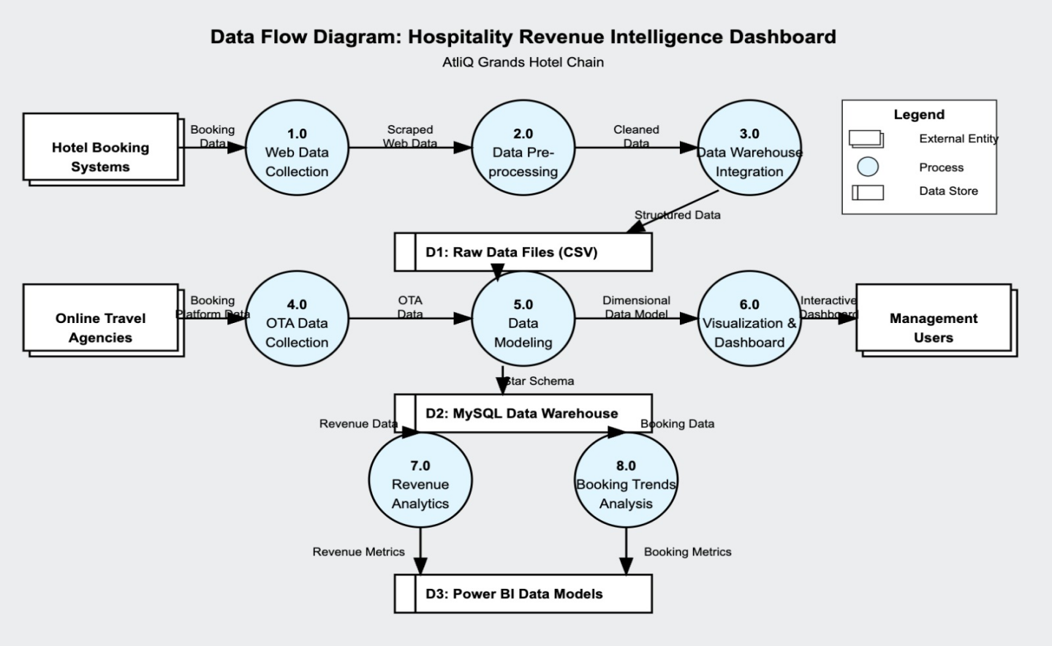

**ER Diagram**

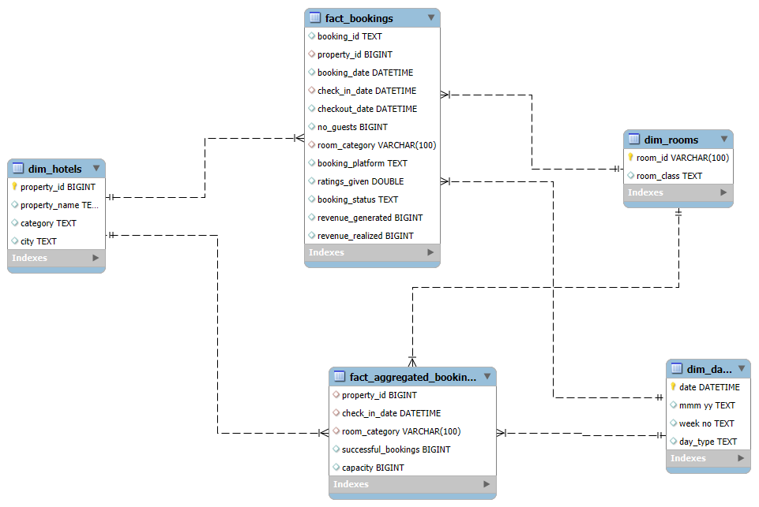

This ER diagram represents a star schema for a hotel booking data warehouse. The central fact tables—fact_bookings and fact_aggregated_bookings—store transitional and aggregated booking data, respectively, including information like booking dates, guest count, room category, platform, revenue, and occupancy metrics. These fact tables are connected to several dimension tables: dim_hotels (describing hotel properties with name, category, and city), dim_rooms (defining room categories and classes), and dim_date (providing temporal attributes like month, week, and day type). Relationships between tables are established through foreign keys such as property_id, room_category, and date fields, enabling multidimensional analysis for reporting on hotel performance, room utilization, and booking trends over time.

**V. Requirements for Proposed Work**

**Software Requirements**

* **Operating System**: Windows, Linux
* **User Interface**: Power BI, Python
* **Database**: MySQL
* **Backend**: Python (for data processing)

**Hardware Requirements**

* **Processor**: Pentium-based systems with a minimum of P4
* **RAM**: 256MB (minimum)
* **Hard Disk**: 10GB Hard Disk Space

**VI. Bibliography/References**

1. Kaggle Datasets: [Hotel Booking Dataset](https://www.kaggle.com/)
2. Power BI Documentation: [Power BI Reports](https://docs.microsoft.com/en-us/power-bi/)
3. MySQL Official Documentation: [MySQL Reference Manual](https://dev.mysql.com/doc/)
4. Python Web Scraping: [BeautifulSoup & Scrapy Documentation](https://www.crummy.com/software/BeautifulSoup/)